

SCHOOL *of* BUSINESS AND TECHNOLOGY

Department of Engineering and Aviation Sciences

**Design of Scalar Network Analyzer**

**Colin Anderton**

**Tayveon Lee**

Advisor: Dr. Zhang

February. 23rd, 2024

Design of Scalar Network Analyzer

By

Colin Anderton, Tayveon Lee

Submitted to the Department of Engineering and Aviation Sciences in partial fulfillment of the requirements for the degree of Bachelor of Science in Engineering at the

UNIVERSITY OF MARYLAND EASTERN SHORE

Date

The author hereby grants the University of Maryland Eastern Shore permission to reproduce and distribute publicly, paper and or electronic copies of this document in whole or in parts.

Authors Colin Anderton, Tayveon Lee

Signature

Date

Department of Engineering and Aviation Sciences

Certified by

**List of Contents**

**1.1 Background/Motivation 5**

Fig 1.1 SA124B Spectrum Analyzer 6

Fig 1.2 TG124A Tracking Generator 6

**1.2 Objective 6**

**1.3 Design Requirements 6**

**1.4 Design Constraints 7**

**1.5 Design Methods 7**

**1.6 Standards 8**

**2.1 System Description 9**

**2.2 System Diagram (or Flow Chart) 9**

Figure 2.2 LabView Logic Diagram 9

**2.3 System Functions 9**

**3.1 Tasks 10**

**3.2 Team Organization 10**

1.1.1 Responsibility of Colin Anderton 10

1.1.2 Responsibility of Tayveon Lee 10

**3.3 Timeline/Milestones/Delivery Plan 10**

**4.1 Implementation of Task 1.1: 13**

Figure 4.1 Task 1.1 Labview Diagram 13

**4.2 Implementation of Task 1.3 14**

**List of Figures**

**1.1 Background/Motivation 5**

Fig 1.1 SA124B Spectrum Analyzer 6

Fig 1.2 TG124A Tracking Generator 6

**1.2 Objective 6**

**1.3 Design Requirements 6**

**1.4 Design Constraints 7**

**1.5 Design Methods 7**

**1.6 Standards 8**

**2.1 System Description 9**

**2.2 System Diagram (or Flow Chart) 9**

Figure 2.2 LabView Logic Diagram 9

**2.3 System Functions 9**

**3.1 Tasks 10**

**3.2 Team Organization 10**

1.1.1 Responsibility of Colin Anderton 10

1.1.2 Responsibility of Tayveon Lee 10

**3.3 Timeline/Milestones/Delivery Plan 10**

**4.1 Implementation of Task 1.1: 13**

Figure 4.1 Task 1.1 Labview Diagram 13

**4.2 Implementation of Task 1.2 16**

**List of Tables**

Table 1. Project Timeline and Delivery Plan 10

**Abstract**

1. **Introduction**

The project objective is to design a Scalar Network Analyzer system that includes signal capturing equipment from Signal Hound, LabView software to display and save the acquired data, and an RF Circuit to test the equipment thoroughly.

## Background/Motivation

The purpose of this project is to develop a scalar network analyzer that contains all capabilities and requirements as defined in section 1.3. With these specific requirements in mind, there will be a scalar network analyzer designed to eliminate wasteful features and provide new more useful features. This scalar network analyzer will also be a cost efficient solution in comparison to the Keysight 8757D.

The system that is to be designed is intended to be a custom made Scalar Network Analyzer system, LabView Software, and an RF test circuit for the purposes of capturing output data from a Magnetron and displaying it for visual inspection. The RF test circuit is intended to be a test circuit for the system to allow for calibration and testing during the project.

Currently, there are devices that can achieve the goals of collecting and displaying data such as the Keysight/Agilent 8757D, however these devices lack the on-board ability to store the data for later use, and does not contain a test circuit to test the system’s calibration before use. Having these additional abilities will streamline the workflow process and allow for data to be easily managed and viewed.

To achieve these goals the project has been split into three different sections of the system. The first goal is to develop the LabView software solution to gathering, displaying, and saving data collected from the system hardware. The second goal is to develop a scalar network analyzer system utilizing components from Signal Hound such as the SA124B and the TG124A. These components by themselves will be unable to be a fully functional scalar network analyzer, however developing a system of these components and the software will create the scalar network analyzer system. The final section of the project is to develop an RF Test Circuit capable of testing our scalar network analyzer system to its full capabilities and to be able to test quickly.

For the hardware system, the SA124B and the TG124A were picked due to their ability to capture such high frequency of waves, and they both are compatible with each other so there can be a created system that will function well together. These were also picked as the solution due to the ability to connect them to the LabView solution to manipulate the data collected from these two pieces of equipment. These two pieces of equipment will require development to integrate them fully together to create our scalar network analyzer.

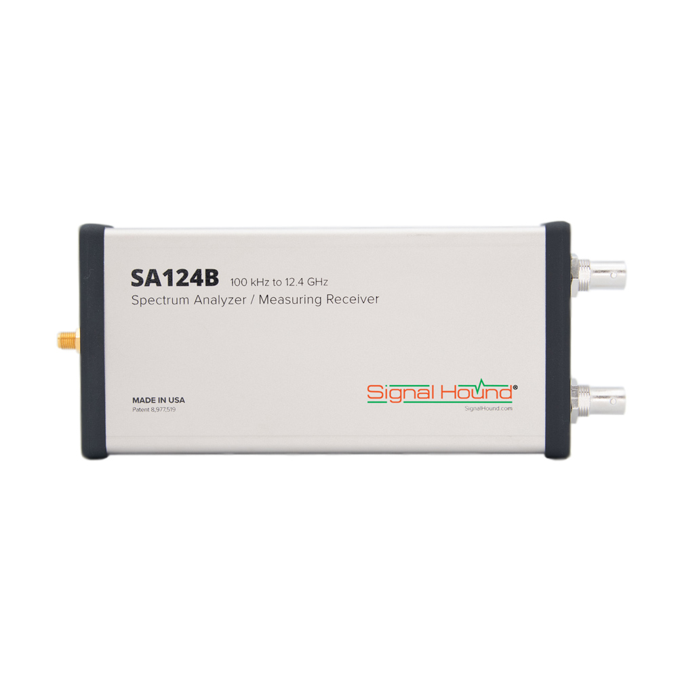

### Fig 1.1 SA124B Spectrum Analyzer

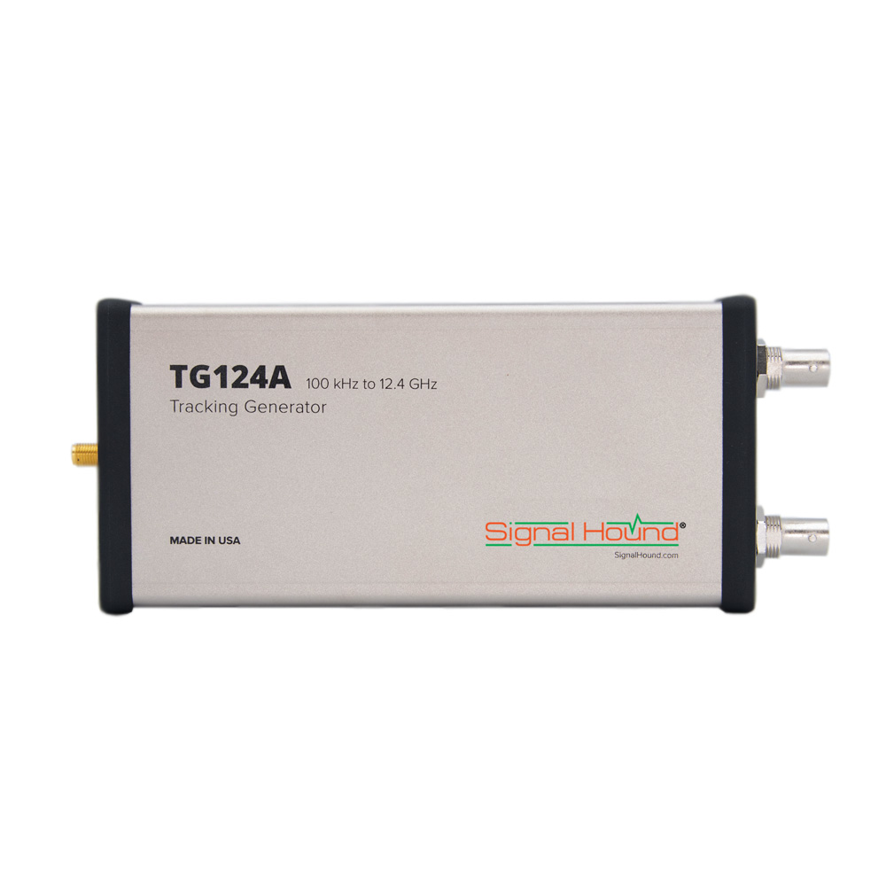

### Fig 1.2 TG124A Tracking Generator

The software portion of this project is going to be done via LabView due to the compatibility between the signal hound equipment and the data acquisition and manipulation abilities of the LabView software. LabView was also picked due to its capabilities when it comes to storing and calibration of the signal hound equipment and how easily it can recall historical data and display that data. Lastly, the LabView software also has the display capabilities that were required by this project, and LabView can display the data extremely well.

## Objective

To create a functioning and efficient Scalar Network Analyzer utilizing Signal Hound equipment that is able to read the frequency range, and be able to display, save, and recall historical data.

## Design Requirements

Task 1 - LabView Software Design

* Store and Recall data
* Analyze data to retrieve Attenuation, Gain, VSWR, and Return Loss
* Display live data with minimal system lag.
* Utilize calibration standards sent by Hill Park Engineering.

Task 2 - Scalar Network Analyzer Hardware System Development

* Develop the Hardware to be efficient in signal processing.
* Reduce loss in signal strength/properties via the use of proper and efficient cables.

Task 3 - RF Test Circuit Design

* Design the RF Test Circuit to be Discreet.
* Signal Range of 100khz to 12.4ghz.
* Designed to be repeatable

Task 4 - Scalar Network Analyzer Enclosure Design

* Construct Enclosure to allow portability of the Scalar Network Analyzer.
* Ensure that the Enclosure does not thermally compromise the Scalar Network Analyzer.

Task 5 - Testing, Comparison, and Revisions (Not a Design Task)

* Test and compare system to a Keysight/Agilent 8757D.
* Make revisions to make the signal hound system comparable to the 8757D

## Design Constraints

* Loss of accuracy between the spectrum analyzer and the tracking generator via connections/wires.
* How compact the enclosure can be due to heat output of the spectrum analyzer and tracking generator.

## Design Methods

Steps to be taken for each task to be completed

Task 1 - LabView Development

1. Investigate LabView’s connections and determine what actions are needed to complete the project
2. Generate the block diagram based on the conclusions about LabView
3. Create each part of LabView starting with the Conditional Blocks
4. Create the Action Blocks that gather information, do calculations, and calibrate the system.
5. Lastly, Create rough display blocks, don’t worry about making it perfect.
6. Test the LabView software and fix any issues that come up.
7. After confirmation from testing, then go back and re-design the display blocks to look professional and improve functionality.

Task 2 - Signal Hound Hardware

1. Investigate the Hardware and it’s connections that are required.
2. Generate a block diagram of how the system connects together.
3. Connect the system together and ensure connections are all correct.
4. Connect the Signal Hound to the LabView software to confirm the system is properly connected.
5. Connect the RF test circuit to the Signal Hound Hardware and confirm operability between Signal Hound and LabView.

Task 3 - RF Test Circuit

1. Research RF Test Circuits and what components are required to complete the circuit.
2. Pick components based on the design requirements for the RF test circuit.
3. Build RF test circuit.
4. Connect RF Test circuit to a scalar network analyzer to confirm the RF test circuit’s operability before testing the Signal Hound and LabView software.

Task 4 - Enclosure

1. Take measurements of the Signal Hound system to determine the minimum space required in the enclosure.
2. Ensure there is enough airflow into and out of the enclosure to hit temperature specifications for the Signal Hound.
3. Build enclosure out of material that meets UL94 V-2 rating and integrate hardware systems into the enclosure.

Task 5 - Testing, Comparison, and Revisions (Not a Design Task)

1. Perform testing on a pre-built spectrum analyzer that is utilized today for a baseline to compare the Signal Hound Spectrum Analyzer to. (Keysight/Agilent 8757D)
2. Perform testing on the custom Signal Hound Spectrum Analyzer solution and compare to the Keysight/Agilent 8757D.
3. Analyze the comparison of the two systems and make revisions to the Signal Hound Spectrum Analyzer to improve functionality and accuracy.

## Standards

* Enclosure Materials - UL 94 Rated, at least a V-2 Rating : burning stops in less than 30 seconds on a vertical specimen; flaming particle drips are allowed. This is to prevent using a flammable material for the enclosure just in case.

1. **Project Description**

## System Description

## System Diagram (or Flow Chart)

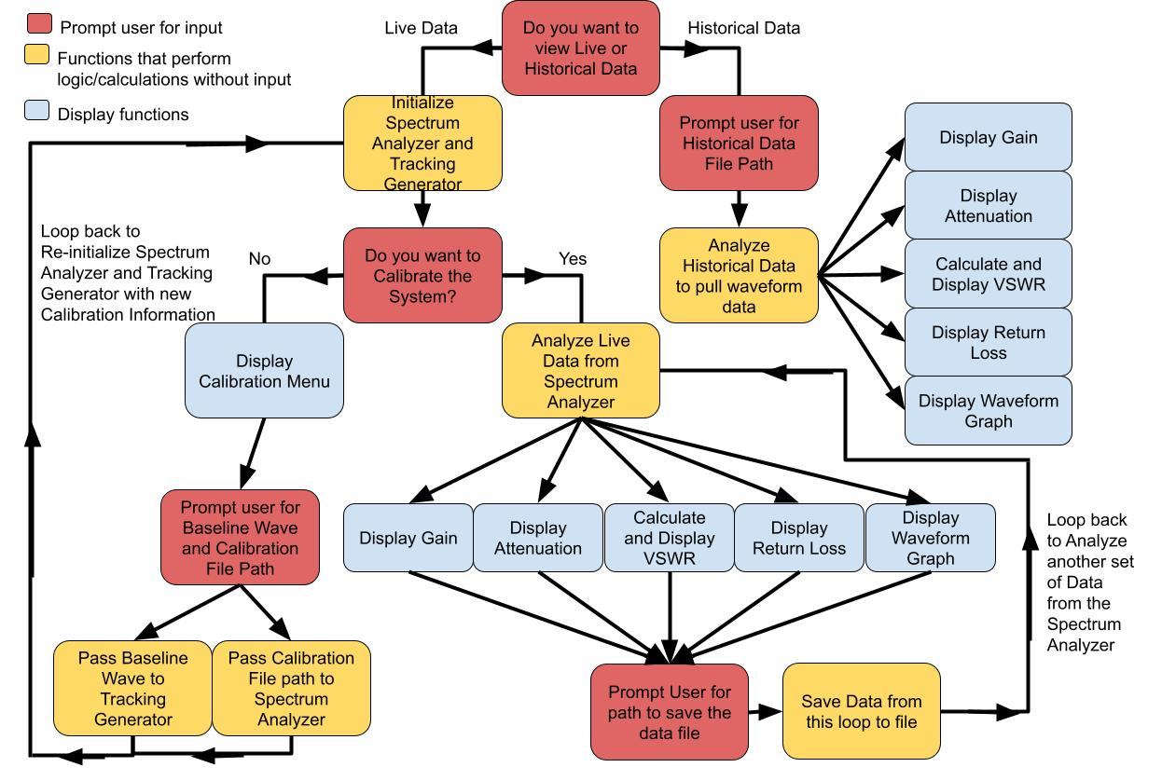

### Figure 2.2 LabView Logic Diagram

## System Functions

1. **Implementation Plan**

## Tasks

Task 1 - LabView Software Design

1.1 - Design LabView software to interface with Signal Hound Hardware.

1.2 - Develop Functions in LabView to manipulate collected data.

1.3 - Create a method of storing data from LabView to an external file.

1.4 - Design a GUI for ease of use and test software fully.

Task 2 - Scalar Network Analyzer Hardware System Development

2.1 - Create a block diagram of connections and logic flow for Hardware.

2.2 - Develop the Signal Hound equipment into a functioning Scalar Network Analyzer and test system.

Task 3 - RF Test Circuit Design

3.1 - Design an RF Test Circuit system diagram adhering to the design specifications defined.

3.2 - Create the RF Test Circuit and test it.

Task 4 - Scalar Network Analyzer Enclosure Design

4.1 - Design a Scalar Network Analyzer enclosure that adheres to the design requirements and standards.

4.2 - Create the enclosure and integrate the Scalar network analyzer hardware into the enclosure.

## Team Organization

There will be two team members, Colin Anderton and Tayveon Lee.

### Responsibility of Colin Anderton

Task 1 and Task 3

### Responsibility of Tayveon Lee

Task 2 and Task 4

## Timeline/Milestones/Delivery Plan

1. **Project Timeline and Delivery Plan**

| Time | Task | | Comments |
| --- | --- | --- | --- |
| Colin Anderton | Tayveon Lee |
| Week 1 | Subtask 1.1 | Subtask 1.1 | Design LabView software to interface with Signal Hound Hardware. |
| Week 2 | Subtask 1.1 | Subtask 1.1 | Design LabView software to interface with Signal Hound Hardware. |
| Week 3 | Subtask 1.1 | Subtask 1.1 | Design LabView software to interface with Signal Hound Hardware. |
| Week 4 | Subtask 1.2 | Subtask 1.2 | Develop Functions in LabView to manipulate collected data. |
| Week 5 | Subtask 1.2 | Subtask 1.2 | Develop Functions in LabView to manipulate collected data. |
| Week 6 | Subtask 1.2 | Subtask 1.2 | Develop Functions in LabView to manipulate collected data. |
| Week 7 | Subtask 1.3 | Subtask 1.3 | Create a method of storing data from LabView to an external file. |
| Week 8 | Subtask 1.3 | Subtask 1.3 | Create a method of storing data from LabView to an external file. |
| Week 9 | Subtask 1.3 | Subtask 1.3 | Create a method of storing data from LabView to an external file. |
| Week 10 | Subtask 1.4 | Subtask 1.4 | Design a GUI for ease of use and test software fully. |
| Week 11 | Subtask 1.4 | Subtask 1.4 | Design a GUI for ease of use and test software fully. |
| Week 12 | Subtask 2.1 | Subtask 2.1 | Create a block diagram of connections and logic flow for Hardware. |
| Week 13 | Subtask 2.1 | Subtask 2.1 | Create a block diagram of connections and logic flow for Hardware. |
| Week 14 | Subtask 3.1 | Subtask 2.1 | Create a block diagram of connections and logic flow for Hardware. Design an RF Test Circuit system diagram adhering to the design specifications defined. |
| Week 15 | Subtask 3.1 | Subtask 2.2 | Develop the Signal Hound equipment into a functioning Scalar Network Analyzer and test system. Design an RF Test Circuit system diagram adhering to the design specifications defined. |
| Week 16 | Subtask 3.2 | Subtask 2.2 | Develop the Signal Hound equipment into a functioning Scalar Network Analyzer and test system. Create the RF Test Circuit and test it. |
| Week 17 | Subtask 3.2 | Subtask 2.2 | Develop the Signal Hound equipment into a functioning Scalar Network Analyzer and test system. Create the RF Test Circuit and test it. |
| Week 18 | Subtask 3.2 | Subtask 2.2 | Develop the Signal Hound equipment into a functioning Scalar Network Analyzer and test system. Create the RF Test Circuit and test it. |
| Week 19 | Subtask 4-1 | Subtask 4.1 | Design a Scalar Network Analyzer enclosure that adheres to the design requirements and standards. |
| Week 20 | Subtask 4.1 | Subtask 4.1 | Design a Scalar Network Analyzer enclosure that adheres to the design requirements and standards. |
| Week 21 | Subtask 4.2 | Subtask 4.2 | Create the enclosure and integrate the Scalar network analyzer hardware into the enclosure. |
| Week 22 | Subtask 4.2 | Subtask 4.2 | Create the enclosure and integrate the Scalar network analyzer hardware into the enclosure. |

1. **Implementation**

## Implementation of Task 1.1:

Through learning about the functions and logic available in LabView, we have developed the blow logic block diagram that will allow our GUI to interface with the Signal Hound system, and also achieve all the requirements for the software such as Historical/Live data and to Save the data to a file.

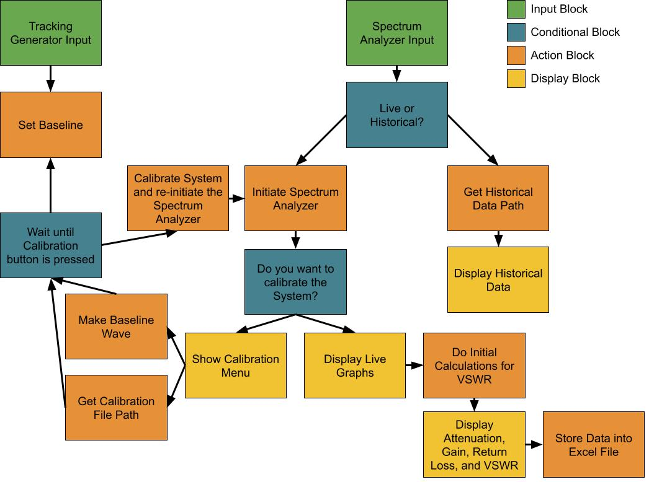

### Figure 4.1 Task 1.1 Labview Diagram

The first step of the program was to develop a method for the user to select either Historical data, or to view Live data. There is a function called “Prompt user for input” which will allow us to create a pop-up dialog box that can give us a true/false value based on what the user selects (Live data which is True, or Historical data which is False).

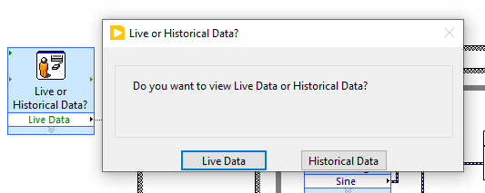

Now that we have a true/false boolean value from this selection from the user, we had to come up with a way to branch between the true/false value in LabView to ensure we give the correct data/options for the user for the next step. With this in mind, we found a Case Structure function that will allow us to pass that Boolean value to switch between two separate paths, one for Live Data, and one for Historical Data.

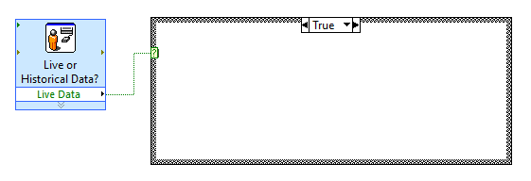

Now that we have the ability to have separate branches for the outcome of the initial prompt, we needed to develop the next prompt for the Live Data branch that would prompt the user to determine if they wanted to calibrate the system before collecting/displaying the live data.We utilized the Prompt user for input and the Case Structure again for the Calibration prompt.

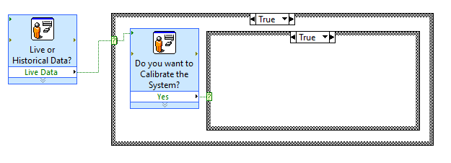

Since the logic behind the branching for the program is now developed, we need to start with the Historical Data path as it is easier to develop and it can be done without the Signal Hounds’ connections. The Historical Data is intended to be run based on a file that is inputted by the user. A few separate functions were tested to see how we could prompt the user for an appropriate file to develop our waveform data. We determined that the Read waveforms from file function would be best suited for our case as the Signal Hounds output a waveform which is saved into a waveform based file. The user will be prompted to give the file path to LabView so that LabView can grab the file.

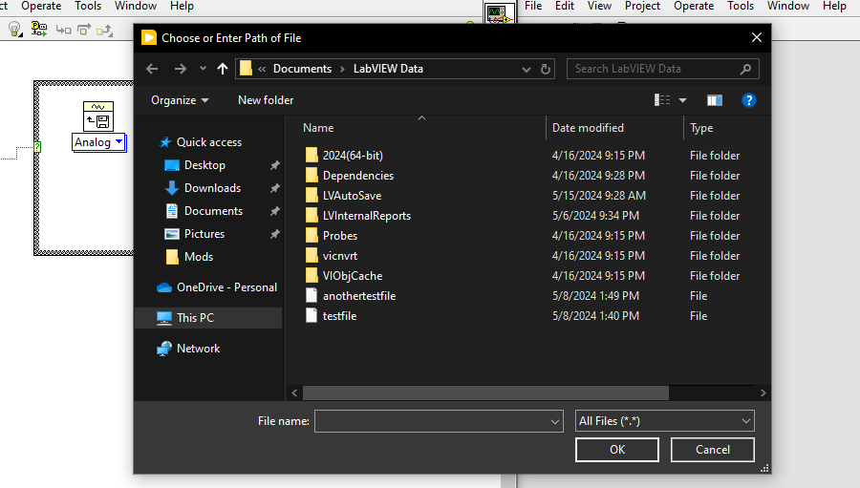

Now that the Historical Data portion’s logic is developed and implemented, we can now start working on the logic behind the Live Data, but more importantly, the Calibration step. The Calibration step is to include uploading a calibration file for the Spectrum Analyzer and then generating a reference waveform for the Tracking Generator. First, we must prompt the user for a calibration file, and to do this we have determined the function File Dialog would suit our purposes by prompting the user for the file path and then passing that file path as a string.

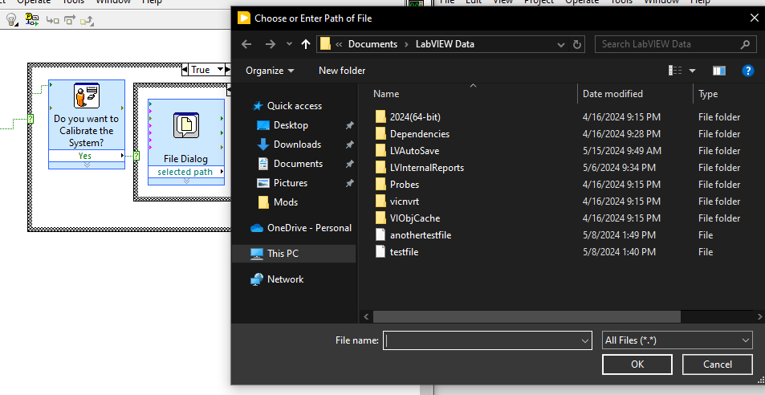

Now that we have the file path, we must find a way to allow the user to set the parameters of a reference waveform that is developed for the Tracking Generator. To do this, it is important to allow the user to have as many parameters as possible to manipulate.

## Implementation of Task 1.2

1. **Project evaluation**
2. **Conclusion**

**Acknowledgement**

**Appendix**

**REFERENCES**